Artist: Shawn Mendes
Song: Stitches

Capo 1

Intro Am |G |C |F ||

Intro/verse Picking:
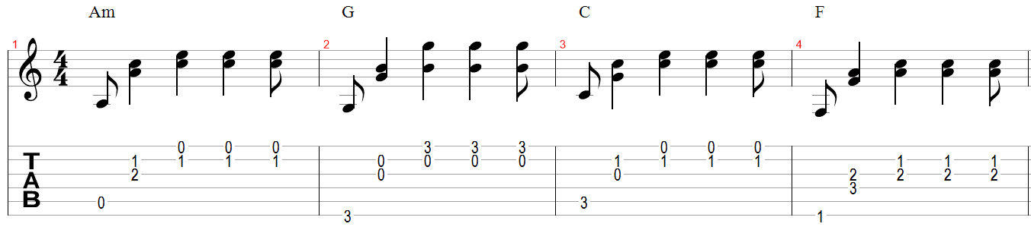

Verse 1
Am G C F
I thought that I've been hurt before
Am G C F
But no one's ever left me quite this sore
Am G C F
Your words cut deeper than a knife
Am G C F
Now I need someone to breathe me back to life

F G Am
Got a feeling that I'm going under but I know that I'll make it out alive
F G Am N.C.
If I quit calling you my lover, move on

Chorus
Am G C F
You watch me bleed until I can't breathe, I'm shaking, falling onto my knees
Am G F C
And now that I'm without your kisses, I'll be needing stitches
Am G C F
Tripping over myself, aching, begging you to come help
Am G F C
And now that I'm without your kisses I'll be needing stitches

Chorus Strumming:

Verse 2
Am G C F
Just like a moth drawn to a flame
Am G C F
Oh, you lured me in, I couldn't sense the pain
Am G C F
Your bitter heart cold to the touch
Am G C F
Now I'm gonna reap what I sow I'm left seeing red on my own

F G Am
Got a feeling that I'm going under but I know that I'll make it out alive
F G Am N.C.
If I quit calling you my lover, move on

Chorus
Am G C F
You watch me bleed until I can't breathe, I'm shaking, falling onto my knees
Am G F C
And now that I'm without your kisses, I'll be needing stitches
Am G C F
Tripping over myself, aching, begging you to come help
Am G F C
And now that I'm without your kisses I'll be needing stitches

Interlude Am |G |C |F ||

Interlude Strumming:
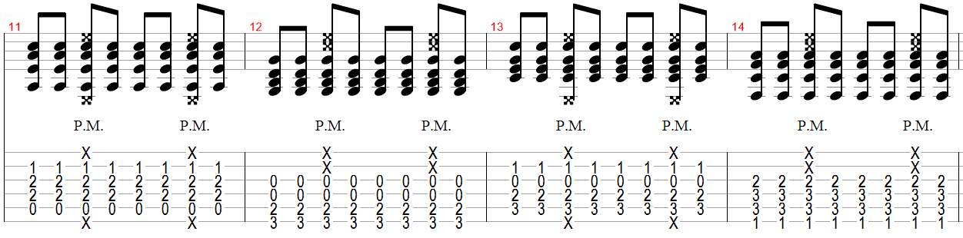

Bridge
Am G
Needle and the thread, gotta get you out of my head
C F
Needle and the thread, gonna wind up dead
Am G
Needle and the thread, gotta get you out of my head
C F
Needle and the thread, gonna wind up dead
Am G
Needle and the thread, gotta get you out of my head
C F
Needle and the thread, gonna wind up dead

Am G C N.C.
Needle and the thread, gotta get you out of my head, get you out of my head

Chorus
Am G C F
You watch me bleed until I can't breathe, I'm shaking, falling onto my knees
Am G F C
And now that I'm without your kisses, I'll be needing stitches
Am G C F
Tripping over myself, aching, begging you to come help
Am G F C
And now that I'm without your kisses I'll be needing stitches (and now that)

N.C.
I'm without your kisses I'll be needing stitches (and now that)

I'm without your kisses I'll be needing stitches

END

