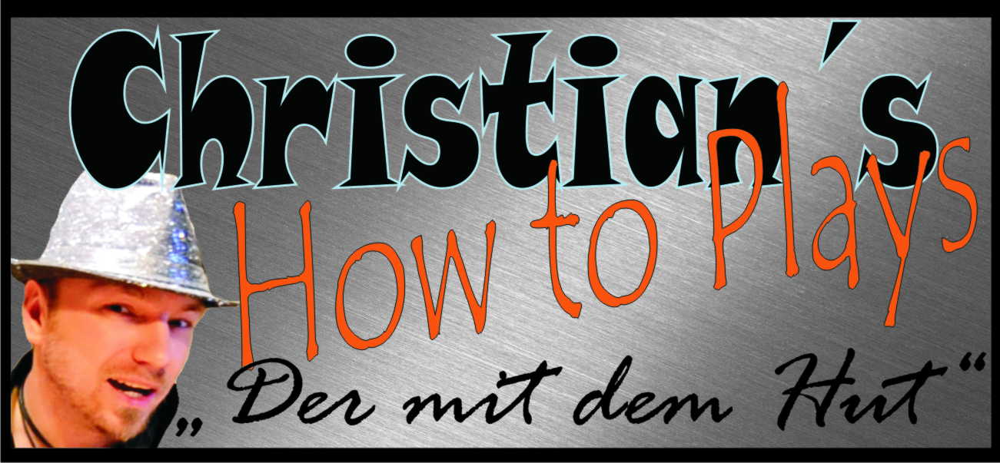

Hallo und herzlich Willkommen zu einem meiner Tabs. Ich hoffe du hast damit viel Erfolg und Spaß. Schreibe mir ruhig eine Meinung zu den Noten, Verbesserungen oder auch pures Lob ist gerne gesehen :-p
Komm doch mal bei einer meiner Seiten vorbei :)

www.christianshowtoplays.de
www.facebook.com/ChristiansHowToPlay
https://twitter.com/ChristiansHowTo
http://www.youtube.com/user/ChristiansHowToPlays
Viel Spaß mit den Noten :)

Artist: Bruno Mars
Title: When I Was Your Man

[Intro]

D7 Dm C
D7 Dm C Em

[Verse 1]

2xAm 2xC 4xDm
Same bed, but it feels just a little bit bigger now
2xG 2xG7 2xC 2xEm
Our song on the radio, but it don't sound the same
2xAm 2xC 4xDm
When our friends talk about you all it does is just tear me down
4xG 2xC
Cause my heart breaks a little when I hear your name

[Prechorus]
2xEm 4xAm 4xEm
It all just sounds like ooh, ooh, oooh, oooh
4xBb 2xC 1xG Stop
Mmm too young, too dumb to realize

[Chorus]
2xF 2xG 4xC
That I should've bought you flowers and held your hand
2xF 2xG 4xC
Shoulda gave you all my hours when I had the chance
2xF 2xG 2xAm
Take you to every party cause all you wanted to do was dance
2xD7 2xF 2xFm 3xC 1xF 3xC 1xEm
Now my baby's dancing, but she's dancing with another man

[Verse 2]

Am C Dm
My pride, my ego, my needs and my selfish ways
G G7 C Em
Caused a good strong woman like you to walk out my life
Am C Dm
Now I'll never, never get to clean up the mess I made ooh
G C
And that haunts me every time I close my eyes

[Refrain]
Em Am Em
It all just sounds like ooh, ooh, oooh, oooh
Bb C
Mmm too young, too dumb to realize

[Chorus]
G F G C
That I should've bought you flowers and held your hand
F G C
Shoulda gave you all my hours when I had the chance
F G Am
Take you to every party cause all you wanted to do was dance
D7 F Fm C
Now my baby's dancing, but she's dancing with another man

[Bridge]

4xF 4xG 2xC 2xG 2xAm 2xEm
Although it hurts I'll be the first to say that I was wrong
4xD7
Oh, I know I'm probably much too late
4xDm
To try and apologize for my mistakes
5xG
But I just want you to know

[Chorus]

F G C
I hope he buys you flowers, I hope he holds your hand
F G C
Give you all his hours when he has the chance
F G Am
Take you to every party cause I remember how much you love to dance
D7 F Fm C
Do all the things I should've done when I was your man
D7 F Fm C
Do all the things I should've done when I was your man

