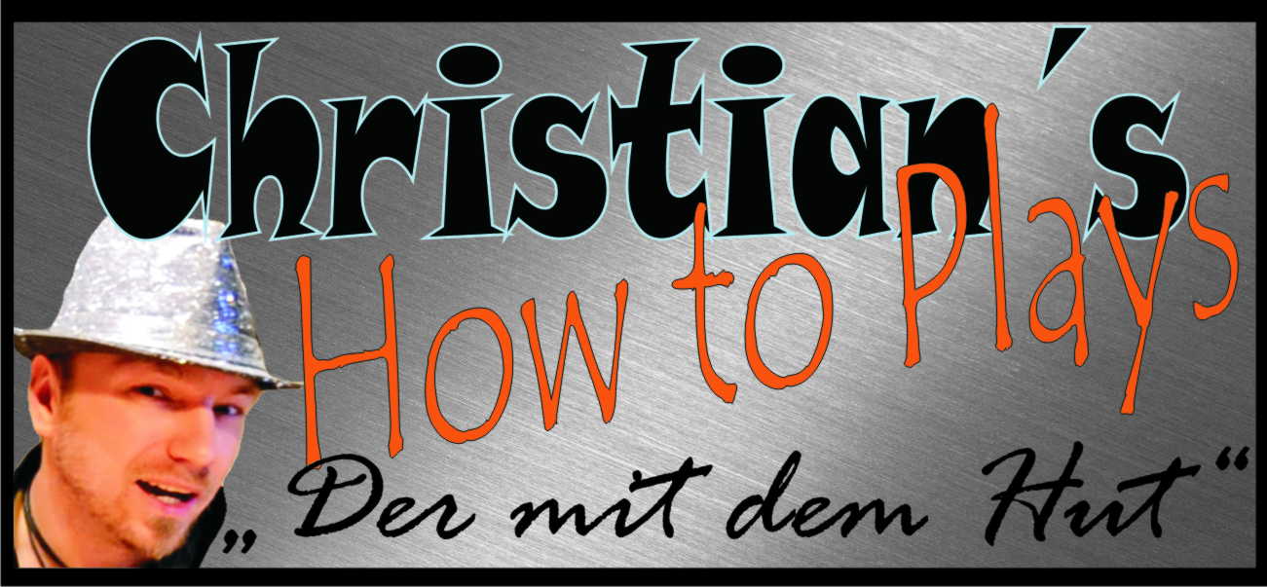

Hallo und herzlich Willkommen zu einem meiner Tabs. Ich hoffe du hast damit viel Erfolg und Spaß. Schreibe mir ruhig eine Meinung zu den Noten, Verbesserungen oder auch pures Lob ist gerne gesehen :-p
Komm doch mal bei einer meiner Seiten vorbei :)

www.christianshowtoplays.de
www.facebook.com/ChristiansHowToPlay
https://twitter.com/ChristiansHowTo
http://www.youtube.com/user/ChristiansHowToPlays
Viel Spaß mit den Noten :)

COUNTING STARS - Onerepublic

Tuning: Standard *CAPO ON 4*

Intro: Am, C, G, F)

e|------0---------0----------0-----------0----------------------------------|
B|------1---------1----------1-----------1----------3-----------3-----------|
G|---2----2----2----2-----0-----0-----0-----0-------0-----------0-----------|
D|-----------------------------------------------0-----0-----0-----0--------|
A|-0---------0---------3-----------3----------------------------------------|
E|--------------------------------------------3-----------3-----------------|

e|------------------------------------|
B|--------1------------1--------------|
G|--------2------------2--------------|
D|-----3-----3------3-----3-----------| X2 On the second repetition, play "F" 4 Times
A|------------------------------------|
E|--1------------1--------------------|

Am, C, G, F

Lately, I've been, I've been losing sleep
Dreaming about the things that we could be
But baby, I've been, I've been playing hard,
Sitting, no more counting dollars
We'll be counting stars, yeah we'll be counting stars

[Instrumental Verse Interlude]

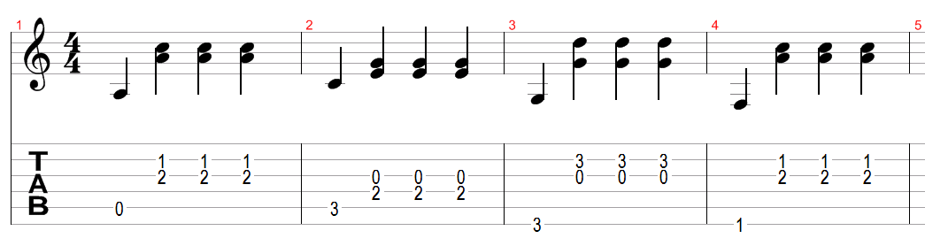

[Melodie]

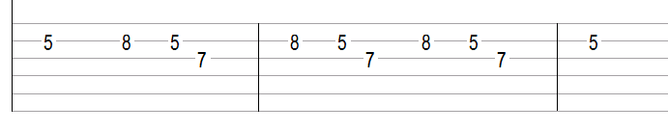

[Verse Picking]

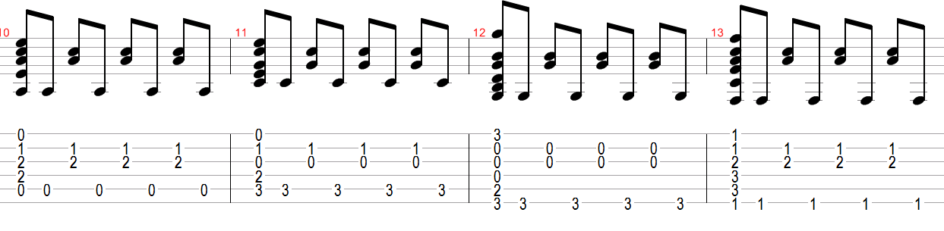

[Verse Chords] (Picking or an offbeat chord strumming)

Am
I see this life like a swinging vine
C
Swing my heart across the line
G
And my face is flashing signs
F
Seek it out and you shall find
Am
Oh, but I'm not that old
C
Young, but I'm not that bold
G
I don't think the world is sold
F
I'm just doing what we're told

[Pre Chorus] (Same picking as verse)

Am C G
I feel something so right
F
Doing the wrong thing
Am C G
I feel something so wrong
F
Doing the right thing
F
I could lie, could lie, could lie
F (Stop, no instruments)
Everything that kills me makes me feel alive

[Chorus]

Am C
Lately, I've been, I've been losing sleep
G F
Dreaming about the things that we could be
Am C
But baby, I've been, I've been playing hard,
G
Sitting, no more counting dollars
F
We'll be counting stars

Am C
Lately, I've been, I've been losing sleep
G F
Dreaming about the things that we could be
Am C
But baby, I've been, I've been playing hard,
G
Sitting, no more counting dollars
F
We'll be, we'll be counting stars

[Verse] Am C G F

I feel the love and I feel it burn
Down this river, every turn
Hope is a four-letter word
Make that money, watch it burn
Oh, but I'm not that old
Young, but I'm not that bold
I don't think the world is sold
I'm just doing what we're told

[Pre Chorus] Am C G F

I feel something so wrong
Doing the right thing
I could lie, could lie, could lie
Everything that downs me makes me wanna fly

[Chorus] Am C G F

Lately, I've been, I've been losing sleep
Dreaming about the things that we could be
But baby, I've been, I've been playing hard,
Sitting, no more counting dollars
We'll be counting stars

Lately, I've been, I've been losing sleep
Dreaming about the things that we could be
But baby, I've been, I've been playing hard,
Sitting, no more counting dollars
We'll be, we'll be counting stars

[Interlude (clapping hands)] No Chords, but you can play Am

Take that money
Watch it burn
Sing in the river
The lessons are learnt

Take that money
Watch it burn
Sing in the river
The lessons are learnt

Take that money
Watch it burn
Sing in the river
The lessons are learnt

Take that money
Watch it burn
Sing in the river
The lessons are learnt

F Dm
Everything that kills me makes feel alive

[Chorus] Am C G F

Lately, I've been, I've been losing sleep
Dreaming about the things that we could be
But baby, I've been, I've been playing hard,
Sitting, no more counting dollars
We'll be counting stars

Lately, I've been, I've been losing sleep
Dreaming about the things that we could be
But baby, I've been, I've been playing hard,
Sitting, no more counting dollars
We'll be, we'll be, counting stars

Take that money
Watch it burn
Sing in the river
The lessons are learnt

Take that money
Watch it burn
Sing in the river
The lessons are learnt

Take that money
Watch it burn
Sing in the river
The lessons are learnt

Take that money
Watch it burn
Sing in the river
The lessons are learnt

