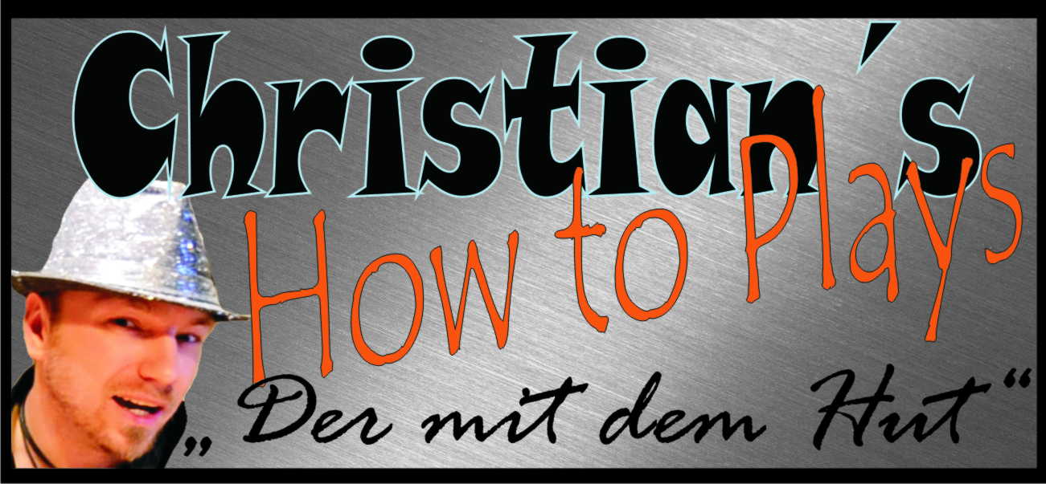

Hallo und herzlich Willkommen zu einem meiner Tabs. Ich hoffe du hast damit viel Erfolg und Spaß. Schreibe mir ruhig eine Meinung zu den Noten, Verbesserungen oder auch pures Lob ist gerne gesehen :-p
Komm doch mal bei einer meiner Seiten vorbei :)

www.christianshowtoplays.de
www.facebook.com/ChristiansHowToPlay
https://twitter.com/ChristiansHowTo
http://www.youtube.com/user/ChristiansHowToPlays
Viel Spaß mit den Noten :)

Daniel Powter - Bad Day Guitar Chords, Lyrics, Tabs and Meanings
Capo 1.

[Intro:] D G A D G

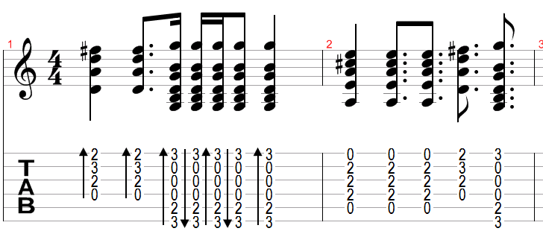
[Verse]
D G A D G
Where is the moment when we need it the most
D G A D G
You kick up the leaves and the magic is lost
Bm A G
They tell me your blue sky's faded to grey
D Em
The tell me your passion's gone away
A G A
And I don't need no carrying on
D G A D G
Stand in the line just to hit a new low
D G A D G
You're faking a smile with the coffee you go
Bm A G
You tell me your life's been way off line
D Em
You're falling to pieces everytime
A
And I don't need no carrying on
[Chorus:]
D
Cause you had a bad day
G
You're taking one down
Em A
You sing a sad song just to turn it around
D
You say you don't know
G
You tell me don't lie
Em A
You work at a smile and you go for a ride
Bm
You had a bad day
A
The camera don't lie
G D
You're coming back down and you really don't mind
Em A
You had a bad day
D
You had a bad day
[Bridge]
D G A G x 2
[PreChorus]
Bm A G
Well you need a blue sky holiday
D Em
The point is they laugh at what you say
A
And I don't need no carrying on
[Chorus:]
D
Cause you had a bad day
G
You're taking one down
Em A
You sing a sad song just to turn it around
D
You say you don't know
G
You tell me don't lie
Em A
You work at a smile and you go for a ride
Bm
You had a bad day
A
The camera don't lie
G D
You're coming back down and you really don't mind
Em A
You had a bad day
[Bridge]
F
Sometimes the system goes on the blink
Bb
And the whole thing it turns out wrong
F
You might not make it back and you know
Bb
That you could be well oh that strong
A
Well I'm not wrong
[Quite Interlude]
D G A
So where is the passion when you need it the most
G
Oh you and I
D G A *stop*
You kick up the leaves and the magic is lost
[Chorus:]
D
Cause you had a bad day
G
You're taking one down
Em A
You sing a sad song just to turn it around
D
You say you don't know
G
You tell me don't lie
Em A
You work at a smile and you go for a ride
Bm
You had a bad day
Bm
It seem what you like
Bm7 Bm6
And how does it feel for one more time
A
You had a bad day
D G Em A x4 (fade out)
had a bad day

