Artist: David Pfeffer
Song: Im Here

Capo on 3th fret

Intro/Verse Picking:

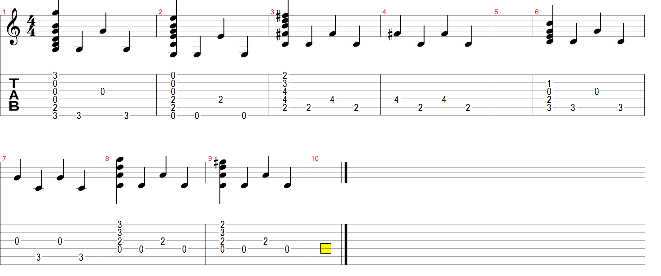

-Intro-
G Em7 Bm

-Verse 1-
G Em7 Bm
It's not a shame to be afraid
G Em7 Bm
I know you trying to be brave
G Em7 Bm
but I know that it's OK
C Dus4 D
you can let your heart go

-Verse 2-
G Em7 Bm
I can't erase your pain
G Em7 Bm
but I do my best to keep you safe
G Em7 Bm
I know it's hard to trust
C Dus4 D
you can count on me oooohou

-Refrain 1-
Em
If I had to face the darkest night
Bm
through the wildest storm
C G D
just to let you know

Em
I would give up everything
Bm
just to keep you on
C G D
anything to show you
Cmaj7 Dsus4 D
I'm here
Cmaj7 Dsus4 D
I'm here

-Verse 3-
G Em7 Bm
I don't believe in destiny
G Em7 Bm
but you mean everything to me

G Em7 Bm
I'm not the counter used so million words

C Dsus4 D
even if I want it too

-Refrain 2-
Em
And if I had to face the darkest night
Bm
through the wildest storm
C G D
just to let you know
Em
I would give up everything
Bm
just to keep you on

C G D
anything to show you

Cmaj7 Dsus4 D
I'm here
B7 Em D
I'm here oooooohooooh

-Bridge-
C
I can't paint the picture but
Dsus4 D
I might get it wrong
B7
and I could tell a story
Em D
but it might go on too long
C Dsus4 D
And I could join an orchestra pretend to play along
B7 Em D
sometimes I might be lost for words

Cmaj7 Dsus4 D
I'm here
Cmaj7
I'm here

-Refrain 3-
Em
And if I had to face the darkest night
Bm
through the wildest storm
C G D
just to let you know

Em
I would give up everything
Bm
just to keep you on

C G D
anything to show you

Cmaj7 Dsus4 D
I'm here

Cmaj7

-End-

2.) I'm here - David Pfeffer
(tabbed by nuageux)

Capo 3th fret

-Intro-
G Bm

-Verse 1-
G Bm
It's not a shame to be afraid
G Bm
I know you trying to be brave
G Bm
but I know that it's OK
Am G D
you can let your heart go

G Bm
I can't erase your pain
G Bm
but I do my best to keep you safe
G Bm
I know its hard to trust
Am G D
you can count on me ooohou

-Refrain-
Em
If I had to face the darkest night
Bm
through the wildest storm
C G D
just to let you know

Em
I would give up everything
Bm
just to keep you on
C G D
anything to show you
Em G D
I'm here
Em G D
I'm here

-Verse 2-
G Bm
I don't believe in destiny
G Bm
but you mean everything to me
G Bm
I'm not the counter used so million words

Am G D
even if I want it too

-Refrain-
Em
And if I had to face the darkest night
Bm
through the wildest storm
C G D
just to let you know
Em
I would give up everything
Bm
just to keep you on
C G D
anything to show you

Em G D
I'm here
Bm Bm D
I'm here ooohohooooh

-Bridge-
C
I can't paint the picture but
G
I might get it wrong
Bm
and I could tell a story
D
but it might go on too long
C G
And I could join an orchestra pretend to play along
Bm G D
sometimes I might be lost for words

Em G D
I'm here
Em
I'm here G

-Refrain-
Em
And if I had to face the darkest night
Bm
through the wildest storm
C G D

just to let you know
Em
I would give up everything
Bm
just to keep you on

C G D
anything to show you

Em G D
I'm here

Em

-End-

END

