James Arthur – Impossible Chords
Capo: 3.
[Verse I]
Am
I remember years ago
C
Someone told me I should take
G
Caution when it comes to love
F
I did
Am
And you were strong and I was not
C
My illusion, my mistake
G
I was careless, I forgot
F
I did

[PreChorus]
Dm
And now when all is done
Em
There is nothing to say
F
You have gone and so effortlessly
G
You have won, you can go ahead tell them

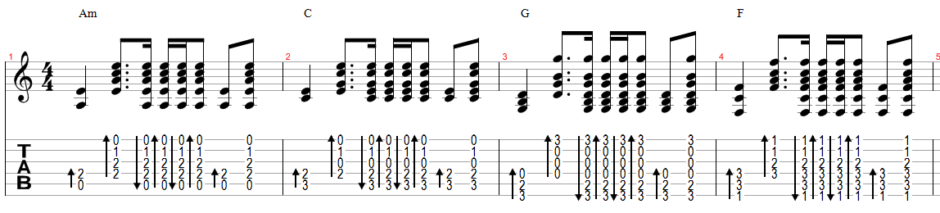

[Chorus]
Am
Tell them all I know now
C
Shout it from the rooftops
G
Write it on the skyline
F
All we had is gone now
Am
Tell them I was happy
C
And my heart is broken
G
All my scars are open
F
Tell them what I hoped would be
Am C
Impossible, impossible
G F
Impossible, impossible

[Verse I]
Am
Falling out of love is hard
C
Falling for betrayal is worst
G
Broken trust and broken hearts
F
I know, I know...
Am
Thinking all you need is there
C
Building faith on love is worst
G
Empty promises will wear
F *Pause
I know (I know)

[Refrain]
Dm
And now when all is done
Em
There is nothing to say
F
And if you're done with embarrassing me
G
On your own you can go ahead tell them

[Chorus]
Am
Tell them all I know now
C
Shout it from the rooftops
G
Write it on the skyline
F
All we had is gone now
Am
Tell them I was happy
C
And my heart is broken
G
All my scars are open
F
Tell them what I hoped would be
Am C
Impossible, impossible
G F
Impossible, impossible

Am
I remember years ago
C
Someone told me I should take
G
Caution when it comes to love
F
I did

*The timing changes a little bit on this part,
listen to the song if you
Am
Tell them all I know now
C
Shout it from the rooftops
G
Write it on the skyline
F
All we had is gone now
Am
Tell them I was happy
C
And my heart is broken
G
OhhwohhOhh
F
I hoped would be
Am C
Impossible, impossible
G F
Impossible, impossible
Am C
Impossible, impossible
G F
Impossible, impossible

