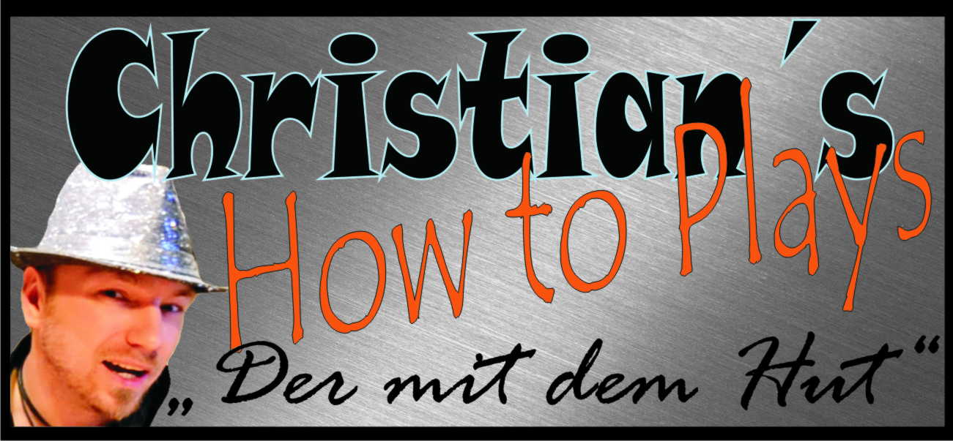

Hallo und herzlich Willkommen zu einem meiner Tabs. Ich hoffe du hast damit viel Erfolg und Spaß. Schreibe mir ruhig eine Meinung zu den Noten, Verbesserungen oder auch pures Lob ist gerne gesehen :-p
Komm doch mal bei einer meiner Seiten vorbei :)

www.christianshowtoplays.de
www.facebook.com/ChristiansHowToPlay
https://twitter.com/ChristiansHowTo
http://www.youtube.com/user/ChristiansHowToPlays
Viel Spaß mit den Noten :)

Artist : James Blunt
Song : Bonfire Heart

Standard tuning
No Capo

INTRO : (Listen carefully to the song for the fingerpicking pattern)

E|----------------------------I-----------------------------|I
B|-----1-------------1--------I-----1-------------1---------|I
G|--------0-------------0-----I--------0-------------0------|I
D|----------2-------------2---I----------2--------------2---|I
A|--3-------------3-----------I--3-------------3------------|I
E|----------------------------I-----------------------------|I

VERSE :

E|----------------------------I----------------------------|
B|-----1-------------1--------I-----1-------------1--------|
G|--------0-------------0-----I--------0-------------0-----|
D|----------2-------------2---I----------2--------------2--|
A|--3-------------3-----------I--3-------------3-----------|
E|----------------------------I----------------------------|

E|----------------------------I----------------------------|
B|-----0-------------0--------I-----0-------------0--------|
G|--------0-------------0-----I--------0-------------0-----|
D|----------2-------------2---I----------2--------------2--|
A|----------------------------I----------------------------|
E|--0-------------0-----------I--0-------------0-----------|

Keep this fingerpicking pattern for the whole song, but change it to these chords (thanks to Tsg9) :

VERSE 1 :
C Em
Your mouth is a revolver firing bullets in the sky.
C Em
Your love is like a soldier, loyal till you die.
F Am
And I've been looking at the stars for a long, long time.
C
I've been putting out fires all my life.
G
Everybody wants a flame, but they don't want to get burnt.
C
And today is our turn.

CHORUS :
C Am F
Days like these lead to, nights like this lead to love like ours,
Am G
You light the spark in my bonfire heart.
C Am
People like us, we don't need that much.
F Am G
Just someone that starts, starts the spark in our bonfire hearts.

VERSE 2 :
C Em
This world is getting colder. Strangers passing by.
C Em
No one offers you a shoulder. No one looks you in the eye.
F Am
But I've been looking at you for a long, long time.
C
Just trying to break through, trying to make you mine.
G
Everybody wants a flame, they don't want to get burnt
C
Well today is our turn.

CHORUS :
C Am F
Days like these lead to, nights like this lead to love like ours,
Am G
You light the spark in my bonfire heart.
C Am
People like us, we don't need that much.
F Am G
Just someone that starts, starts the spark in our bonfire hearts.

BRIDGE :

Melodie:
E|-------------|--------------
B|------3-5----|--------3------
G|-5-5---------|--4-4-5--------
D|-------------|--------------
A|-------------|--------------
E|-------------|--------------

G F
Hmm, our bonfire hearts
Am
our bonfire hearts
C
Uh, our bonfire hearts
G
You light the spark

CHORUS :
C Am
People like us, we don't need that much.
F Am G
Just someone that starts, starts the spark in our bonfire hearts.

C Am F
Days like these lead to, nights like this lead to love like ours,
Am G
You light the spark in my bonfire heart.
C Am
People like us, we don't need that much.
F Am G
Just someone that starts, starts the spark in our bonfire hearts.
C
our bonfire hearts

C Am F
Days like these lead to, nights like this lead to love like ours,
Am G
You light the spark in my bonfire heart.
C Am
People like us, we don't need that much.
F Am G
Just someone that starts, starts the spark in our bonfire hearts.

