Artist: Linkin Park
Song: Numb Acoustic

Intro = Chorus: F#m D A E

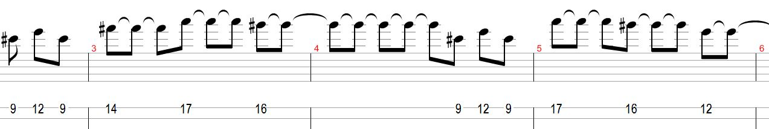

Verse 1:

Bass/Piano

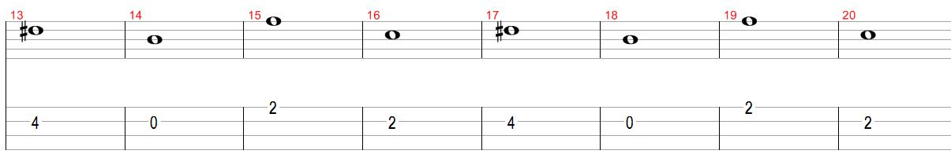

F#m D
I’m tired of being what you want me to be
A
Feeling so faithless
E
Lost under the surface
F#m D
I don’t know what you’re expecting of me
A
Put under the pressure
E D
of walking in your shoes
E
(Caught in the undertow, just caught in the undertow)

Pre Chorus:

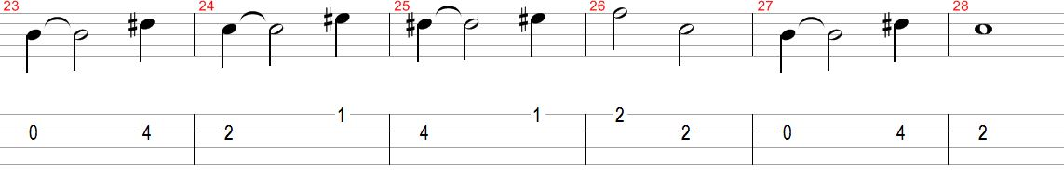

F#m
Every step that I take is
A D
another mistake to you
E
(Caught in the undertow, just caught in the undertow)

Chorus:

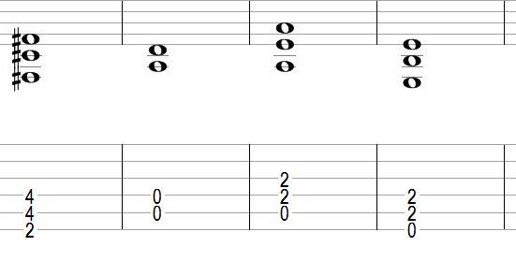

F#m D
I’ve became so numb
A
I can’t feel you there
E
Become so tired
F#m
So much more aware
D
I’m becoming this
A
All I want to do
E
Is be more like me
F#m
And be less like you

Verse 2:

D
Can’t you see that you’re smothering me
A E F#m
Holding too tightly afraid to lose control
D
Cause everything that you thought I would be
A E D
Has fallen apart right in front of you
E
(Caught in the undertow, just caught in the undertow)
F#m
Every step that I take is
A D
another mistake to you
E
(Caught in the undertow, just caught in the undertow)
F#m A
And every second I waste is more than I can take

Chorus:

F#m D
I’ve became so numb
A
I can’t feel you there
E
Become so tired
F#m
So much more aware
D
I’m becoming this
A
All I want to do
E
Is be more like me
F#m
And be less like you

Bridge / End:

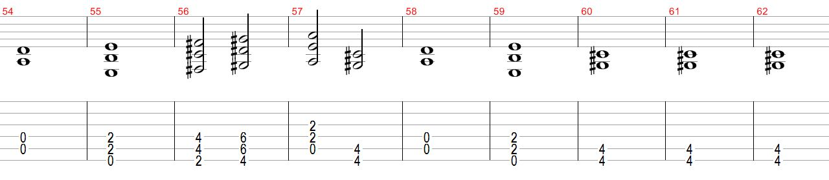

E F#m G#m A C#m D
And I know I may end up failing, too.
E C#m
But I know you were just like me with someone disappointed in you

Chorus:

F#m D
I’ve became so numb
A
I can’t feel you there
E
Become so tired
F#m
So much more aware
D
I’m becoming this
A
All I want to do
E
Is be more like me
F#m
And be less like you

D
I've become so numb
A
I can't feel you there
E
(Tired of being what you want me to be)

F#m D
I've become so numb
A
I can't feel you there
E
(Tired of being what you want me to be)

END

