Olly Murs – Troublemaker

Intro:
G# G Cm
Verse I :
Cm G# G
You had me hooked again from the minute you sat down
Cm
The way you bite your lip
G# G
Got my head spinnin' around
Cm
After a drink or two
G# G
I was putty in your hands
Fm7 G# G
I don't know if I have the strength to stand

Pre Chorus:
Oh oh oh...
Cm Cm D#m Cm
Trouble troublemaker. yeah
That's your middlename
Cm D# Cm
Oh oh oh...
Cm D#m G#
I know you're no good but you're stuck in my brain
And I wanna know

Chorus:
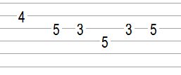
Cm G# G Cm
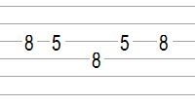
Why does it feel so good but hurt so bad, (wo-o-o-oh)
Cm Fm A# D#
My mind keeps saying, Run as fast as you can
Cm G# G Cm
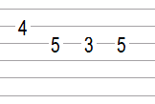
I say I'm done but then you pull me back, (wo-o-o-oh)
Cm Fm A# D#
I swear you're giving me a heart attack... Troublemaker!

Verse II, Pre Chorus II, Chorus II : Like the first Parts

Rap / Flo Rida Part:
Cm G# G Cm

