Paramore — All I Wanted Tab

Tuning: Standard EADGBe

Chords used:
D - xx0232
F#m - 244222
Bm - x24432
A/C# - x476xx
A - x02220

Intro: D--F#m--Bm--A/C#--x2

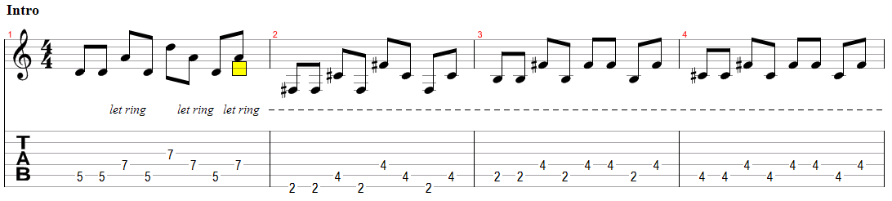

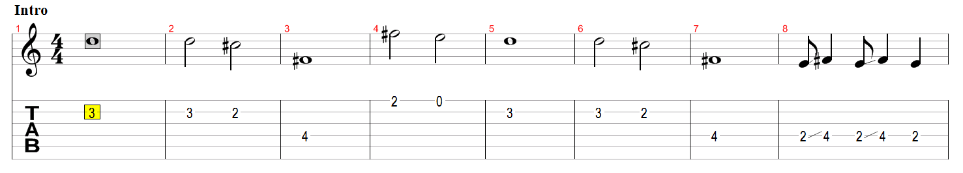

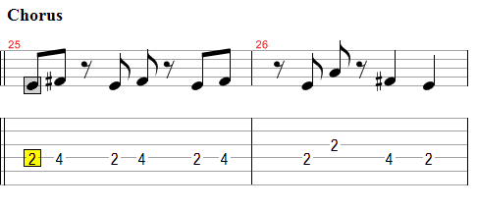

Verse 1:
D
Think of me when you're
F#m Bm A/C#
out when you're out there
D F#m Bm A/C# A
I'll beg you nice from my knees
D
And when the world treats
F#m Bm A/C#
you way too fairly
D F#m Bm A/C#
Well it's a shame I'm a dream

Chorus 1:
D F#m Bm A/C#
All I wanted was you
D F#m Bm
All I wanted was you

Interlude: Distortion
D--F#m--Bm--A/C#-- x2

Verse 2:
D
I think I'll pace my
F#m Bm A/C#
apartment a few times
D F#m Bm A/C#
And fall asleep on the couch
D F#m
And wake up early to black
Bm A/C#
and white re-runs
D F#m Bm A/C#
That escape from my mouth

Chorus 2:
D F#m Bm A/C#
All I wanted was you
D F#m Bm A
All I wanted was you
D F#m Bm A/C#
All I wanted was you
D F#m Bm A/C#
All I wanted was you

Guitar Solo: D--F#m--Bm--A/C#-- x2

Verse 3:
D
I could follow you
F#m Bm A/C#
to the beginning
D F#m Bm A/C#
Just to relive the start
D
And maybe then we'd
F#m Bm A/C#
remember to slow down
D F#m Bm A/C#
At all of our favorite parts

Chorus 3:
D F#m Bm A/C#
All I wanted was you
D F#m Bm A
All I wanted was you
D F#m Bm A/C#
All I wanted was you
D F#m Bm A/C#
All I wanted was you
D F#m Bm A/C# D(hold)
All I wanted was you

