Song: California
Artist: Phantom Planet

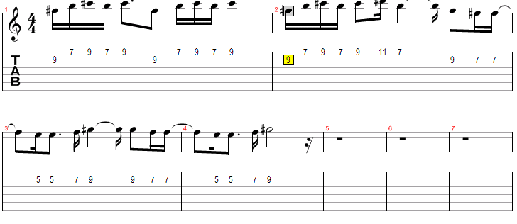

C#m
We've been on the run

Driving in the sun
A E
Looking out for number 1
A E
California here we come
A
Right back where we
E
started from

C#m
Hustlers grab your guns

Your shadow weighs a ton
A E
Driving down the 101
A E
California here we come
A E
Right back where we started from

E A
Californiaaaaaaaaaaaaa !
E A
Here we cooooooooooome!

C#m
On the stereo

Listen as we go
A E
Nothing's gonna stop me now
A E
California here we come
A E
Right back where we started from
C#m
Pedal to the floor

Thinkin' of the roar
A E
Gotta get us to the show
A E
California here we come
A E
Right back where we started from

E A
Californiaaaaaaaaaaaaa!
E A
Here we coooooooooome!

