Artist: Pink
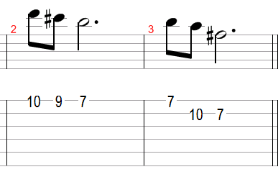
Song: Try
Klavier Melodie Intro:

Strophe:
Bm 1.u.2.u.3 G u.4.u. D 1.u.2.u.3 A u.4.u.
Ever wonder 'bout what he's doing
Bm G D A
How it all turned to lies
Bm G D A
Sometimes I think that it's better
Bm G D A
To never ask why

Bm G D A Bm G D

Refraine:
G D
Where there is desire there is gonna be a flame
A Bm
Where there is a flame someone's bound to get burned
G D
But just because it burns doesn't mean you're gonna die
A Bm
You got to get up and Try, Try,Try
G D
You got to get up and Try, Try,Try
A Bm G D A
You got to get up and Try, Try,Try

Strophe:

Bm G D 2xA 2xBm (Durchgeschlagen)
Bm G D A

