Artist: Shakira
Song: Cant Remember To Forget You

Intro: Bm, Em, A, D
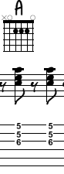
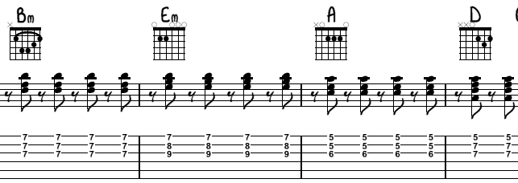

[Shakira]
Bm Em
I left a note on my bedpost
A D A
Said not to repeat yesterday's mistakes
Bm Em
What I tend to do when it comes to you
A D A
I see only the good, selective memory

Bm Em
The way he makes me feel yeah, gotta hold on me
A D A
I've never met someone so different
Oh here we go
Bm Em
He a part of me now, he a part of me
A (pause)
So where you go I follow, follow, follow, oh

[Chorus #1]

Bm A Em
Ohohohoh ohohohoh
G F#
I can't remember to forget you
Bm A G
Ohohohoh ohohohoh
D C#
I keep forgetting I should let you go
Bm A Em
But when you look at me, the only memory
G F#
Is us kissing in the moonlight
Bm A G
Ohohohoh ohohohoh

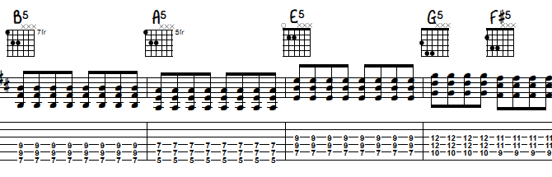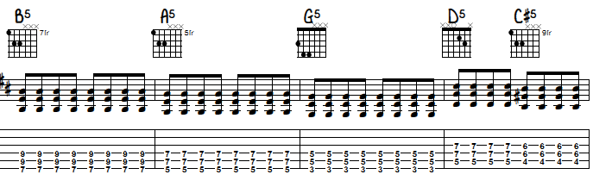
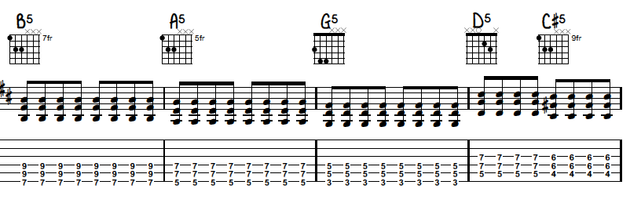

(Pause)

[Bridge]Like Intro/Verse

I can't remember to forget you
Bm Em A
Ooooh
D C#
I can't remember to forget you
Bm Em A D A
Ooooh

[Verse 2: Rihanna]

Bm
I go back again
Em
Fall off the train
A
Land in his bed
D A
Repeat yesterday's mistakes
Bm Em A
What I'm trying to say is not to forget
D A
You see only the good, selective memory

Bm
The way he makes me feel like
Em
The way he makes me feel
A D
I never seemed to act so stupid
A
Oh here we go
Bm Em
He a part of me now he a part of me

[Shakira]
A (pause)
So where he goes I follow, follow, follow, oh

[Verse3: Both]

Bm A Em
Ohohohoh ohohohoh
G F#
I can't remember to forget you
Bm A G
Ohohohoh ohohohoh
D C#
I keep forgetting I should let you go
Bm A Em
But when you look at me, the only memory
G F#
Is us kissing in the moonlight
Bm A G
Ohohohoh ohohohoh
(pause)
I can't remember to forget you

[Bridge: Shakira]

Bm Em
I rob and I kill to keep him with me
A D A
I do anything for that boy
Bm Em
I'd give my last dime to hold him tonight
A D
I do anything for that boy

[Bridge Cont.: Rihanna]
Bm Em
I rob and I kill to keep him with me
A D A
I do anything for that boy
Bm Em
I'd give my last dime to hold him tonight
A D
I do anything for that boy

[Chorus 3: Both]

Bm A Em
Ohohohoh ohohohoh
G F#
I can't remember to forget you
Bm A G
Ohohohoh ohohohoh
D C#
I keep forgetting I should let you go
Bm A Em
But when you look at me, the only memory
G F#
Is us kissing in the moonlight
Bm A Em
Ohohohoh ohohohoh
G F#
I can't remember to forget you
Bm A Em
But when you look at me, the only memory
G F#
Is us kissing in the moonlight
Bm A G
Ohohohoh ohohohoh
(pause)
I can't remember to forget you

