Swing Life Away (Acoustic Version)
Rise Against

Intro Riff x3

Intro

e--------------------x-x-x-x-x-x-x-x-x--------]--x-x-x-x-x-x-x-x-------------|I
B---0----------------3-3-3-3-3-3-3-3-3--------]--3-3-3-3-3-3-3-3-------------|I
G-----0----2--0------0-0-0-0-0-0-0-0-0--------]--2-2-2-2-2-2-2-2-------------|I{x3)
D-------0-------4----0-0-0-0-0-0-0-0-0--------]--0-0-0-0-0-0-0-0-------------|I
A--------------------3-0-0-0-0-0-0-0-0--------]------------------------------|I
E---0------3---------x-x-x-x-x-x-x-x-x--------]------------------------------|I

Anschlag:

Em G C
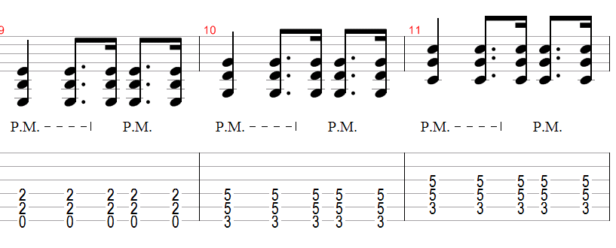

Verse:

Em G C (2)
Am I loud and clear, or am I breaking up?
Em G C (2)
Am I still your charm, or am I just bad luck?
Em G C (2) D (4, hold 4th measure)
Are we getting closer, or are we just getting more lost?

Em G C (2)
I'll show you mine if you show me yours first
Em G C (2)
Let's compare scars, I'll tell you whose is worse
Em G C (2) D (4, hold 4th measure)
Let's unwrite these pages and replace them with our own words

Chorus:

Em C G Am
We live on front porches and swing life away,
Em C D (2)
We get by just fine here on minimum wage
Em C G Am
If love is a labor I'll slave 'till the end,
Em C D (4, hold 4th measure)
I won't cross these streets until you hold my hand

Verse:

Em G C (2)
I've been here so long, I think that it's time to move
Em G C (2)
The winter's so cold, summer's over too soon
Em G C (2) D (4, hold 4th measure)
Let's pack our bags and settle down where palm trees grow

Em G C (2)
I've got some friends, some that I hardly know
Em G C (2)
But we've had some times I wouldn't trade for the world
Em G C (2) D (4, hold 4th measure)
We chase these days down with talks of the places that we will go

Chorus (don't hold last measure)

Solo

Em G C G
C G (Em) D
Em G C G C G Am C

Outro

Em7 G Cadd9 (2)
Swing life away
Em7 G Cadd9 (2)
Swing life away
Em7 G Am C
Swing life away
Em7 G Cadd9 (4)
Swing life away

End on G

---------------------------|
---0------3----------------|
-----0----0----------------|
-------0--0----------------|
----------2----------------|
----------3----------------|

SOLO

e-x--x--x----x--x--x--0--x--0----x--x--x---0--x--0---x--x--x--0------x--x—-x-|
B-0--1--3----3--3--3--1--3--1----3--3--3---1--3--1---3--3--3--0------3--3--3-|
G-0--0--0----0--0--0--0--0--0----0--0--0---0--0--0---0--0--0--0----0-2--2--2-|
D-2--2--2----0--0--0--2--2--2----0--0--0---2--2--2---0--0--0--2--4---0--0--0-|
A-2--2--2----2--2--2--3--3--3----2--2--2---3--3--3---2--2--2--2--------------|I
E-0--0--0----x--x--x------------------------------------------0--------------|I

e-3--x--x--------------0--x--0-------------0--x--0---------------------------|I
B-x--3--1---3--3--3----1--3--1---3--3--3---1--3--1---3--3--3-----------------|I
G-0--0--0---0--0--0----0--0--0---0--0--0---0--0--0---0--0--0-----------------|I
D-2--2--2---0--0--0----2--2--2---0--0--0---2--2--2---0--0--0-----------------|I
A-2--2--2---2--2--2----3--3--3---2--2--2---3--3--3---2--2--2-----------------|I
E-0--0--0---x--x--x----------------------------------------------------------|I

e----------------------------------------------------------------------------|I
B--1--1--1--1--1--1--1--1--1--1----------3--3--3--3--3--3--3--3--3-----------|I
G--2--2--2--0--0--0--2--2--2--0-----0----0--0--0--0--0--0--0--0--0-----------|I
D--2--2--2--2--2--2--2--2--2--2--4-------0--0--0--0--0--0--0--0--0-----------|I
A--0--0--0--0--0--0--0--0--0--0----------3--3--3--3--3--3--3--3--3-----------|I
E----------------------------------------------------------------------------|I
Throughout solo, attempt to put emphasis on strings 1,2 and 3 to pick out melody.

SONG PROGRESSION:
Intro -------------|x1
Verse -------------|x2
Chorus-------------|x1
Verse -------------|X2
Chorus-------------|x1
Solo -------------|x1
Outro -------------|x1

