Hallo und herzlich Willkommen zu einem meiner Tabs. Ich hoffe du hast damit viel Erfolg und Spaß. Schreibe mir ruhig eine Meinung zu den Noten, Verbesserungen oder auch pures Lob ist gerne gesehen :-p
Komm doch mal bei einer meiner Seiten vorbei :)

www.christianshowtoplays.de
www.facebook.com/ChristiansHowToPlay
https://twitter.com/ChristiansHowTo
http://www.youtube.com/user/ChristiansHowToPlays
Viel Spaß mit den Noten :)

Artist: Wham
Song: Last Christmas

!!! Gitarre einen viertelEN Ton Tiefer !!!

D [x x 0 2 3 2]
Bm [x 2 4 4 3 2]
Bm7 [x 2 4 2 3 2]
Em [0 2 2 0 0 0]
A [0 0 2 2 2 0]
A7 [x 0 2 0 2 0]

INTRO:

D Bm Bm7 Em A A7

CHORUS:
D
Last Christmas I gave you my heart
Bm Bm7
But the very next day you gave it away
Em
This year to save me from tears
A A7
I'll give it to someone special.

D
Last Christmas I gave you my heart
Bm Bm7
But the very next day you gave it away
Em
This year to save me from tears
A A7
I'll give it to someone special.

INTERLUDE / MELODIE: D Bm Bm7 Em A A7

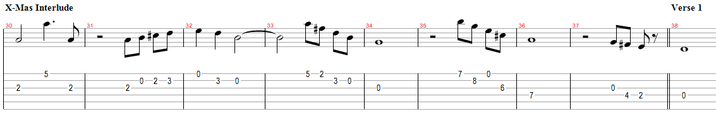

VERSE:

D
Once bitten and twice shy
Bm Bm7
I keep my distance but you still catch my eye
Em
Tell me baby do you recognise me?
A A7
Well it's been a year, it doesn't surprise me.

D
I wrapped it up and sent it
Bm Bm7
With a note saying "I Love You" I meant it
Em
Now I know what a fool I've been
A A7
But if you kissed me now I know you'd fool me again

CHORUS:
D
Last Christmas I gave you my heart
Bm Bm7
But the very next day you gave it away
Em
This year to save me from tears
A A7
I'll give it to someone special.

CHORUS:
D
Last Christmas I gave you my heart
Bm Bm7
But the very next day you gave it away
Em
This year to save me from tears
A A7
I'll give it to someone special.

INTERLUDE / MELODIE: D Bm Bm7 Em A A7

(Oooh. Oooh Baby)

Oooh Oooh

Verse 2:
D
A crowded room friends with tired eyes
Bm Bm7
I'm hiding from you and your soul of ice
Em
My god I thought you were someone to rely on
A A7
Me? I guess I was a shoulder to cry on

Verse 3:
D
A face on a lover with a fire in his heart
Bm Bm7
A man under cover but you tore me apart
Em
Now I've found a real love (now I've found)
A A7
You'll never fool me again

CHORUS:
D
Last Christmas I gave you my heart
Bm Bm7
But the very next day you gave it away
Em
This year to save me from tears
A A7
I'll give it to someone special.

CHORUS:
D
Last Christmas I gave you my heart
Bm Bm7
But the very next day you gave it away
Em
This year to save me from tears
A A7
I'll give it to someone special.

INTERLUDE / MELODIE: D Bm Bm7 Em A A7

D
A face on a lover with a fire in his heart
Bm Bm7
A man under cover buy you tore him apart
Em
Maybe next year I'll give it to someone
A A7
I'll give it to someone special

END

