Artist: Wham
Song: Last Christmas

!!! Gitarre einen viertelEN Ton Tiefer !!!

D [x x 0 2 3 2]
Bm [x 2 4 4 3 2]
Bm7 [x 2 4 2 3 2]
Em [0 2 2 0 0 0]
A [0 0 2 2 2 0]
A7 [x 0 2 0 2 0]

INTRO:

D Bm Bm7 Em A A7

CHORUS:
D
Last Christmas I gave you my heart
Bm Bm7
But the very next day you gave it away
Em
This year to save me from tears
A A7
I'll give it to someone special.

D
Last Christmas I gave you my heart
Bm Bm7
But the very next day you gave it away
Em
This year to save me from tears
A A7
I'll give it to someone special.

INTERLUDE / MELODIE: D Bm Bm7 Em A A7

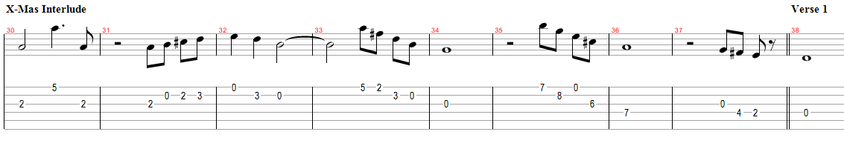

VERSE:

D
Once bitten and twice shy
Bm Bm7
I keep my distance but you still catch my eye
Em
Tell me baby do you recognise me?
A A7
Well it's been a year, it doesn't surprise me.

D
I wrapped it up and sent it
Bm Bm7
With a note saying "I Love You" I meant it
Em
Now I know what a fool I've been
A A7
But if you kissed me now I know you'd fool me again

CHORUS:
D
Last Christmas I gave you my heart
Bm Bm7
But the very next day you gave it away
Em
This year to save me from tears
A A7
I'll give it to someone special.

CHORUS:
D
Last Christmas I gave you my heart
Bm Bm7
But the very next day you gave it away
Em
This year to save me from tears
A A7
I'll give it to someone special.

INTERLUDE / MELODIE: D Bm Bm7 Em A A7

(Oooh. Oooh Baby)

Oooh Oooh

Verse 2:
D
A crowded room friends with tired eyes
Bm Bm7
I'm hiding from you and your soul of ice
Em
My god I thought you were someone to rely on
A A7
Me? I guess I was a shoulder to cry on

Verse 3:
D
A face on a lover with a fire in his heart
Bm Bm7
A man under cover but you tore me apart
Em
Now I've found a real love (now I've found)
A A7
You'll never fool me again

CHORUS:
D
Last Christmas I gave you my heart
Bm Bm7
But the very next day you gave it away
Em
This year to save me from tears
A A7
I'll give it to someone special.

CHORUS:
D
Last Christmas I gave you my heart
Bm Bm7
But the very next day you gave it away
Em
This year to save me from tears
A A7
I'll give it to someone special.

INTERLUDE / MELODIE: D Bm Bm7 Em A A7

D
A face on a lover with a fire in his heart
Bm Bm7
A man under cover buy you tore him apart
Em
Maybe next year I'll give it to someone
A A7
I'll give it to someone special

END

