Artist: Jamestown Story
Song: I Dont Want To Lose You

Intro

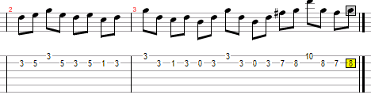

Capo 1
Em C G D
I've been losing sleep for a while now
Em C G D
Thinkin' about us
Em C G D
And its hard to pretend that we're doing okay
C
When we're not
And its killing me slowly

G
I need you in my life
D
Or I'm not alright
C
So don't walk away
G D
I won't be okay if you do

I just don't wanna lose you

Em C G
You've been losing faith
D
For a while now
Em C G
And I'm lost for words
Em C
And though we are having problems
G D
If you are willing we can solve them
In time
C
I'm just begging you to try

G
I need you in my life
D
Or I'm not alright
C
So don't walk away
G D
I won't be okay if you do
I just don't wanna lose you

G
I need you in my life
D
Or I'm not alright
C
Please don't walk away
G
I need you to stay
D
To get through
G
Somethings gotta give
Em C
I hope we can get past all the problems have
G
And let go
D
cause I still believe we have the chance
G
I need you in my life
D
Or I'm not alright
C
So don't walk away
D
I won't be okay if you do
I just don't wanna lose you

G C
Everynight I dream about the days you and I

Both seem so happy
Am C
If only I knew what we'd go through to get here

END

