Artist : Coldplay
Song : Magic
Album : Ghost Stories [2014]

CapoII

INTRO: C - - G/B | D - - G

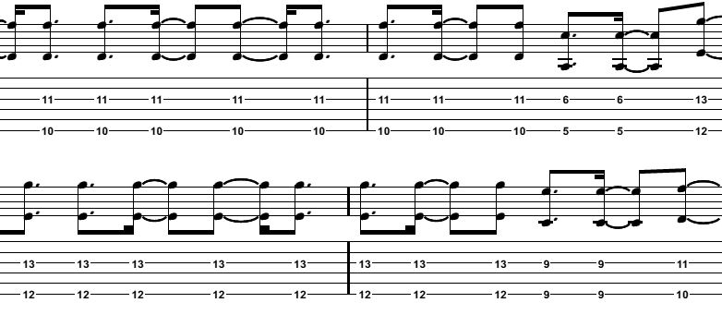

VERSE:
C
Call it magic
G/B D
Call it true
G/B C
I call it magic,
G/B D
When I'm with you
G/B C
And I just got broken
G/B D
Broken into two
G/B C
Still I call it magic,
G/B D G/B
When I'm next to you

CHORUS:

C
And I don't, And I don't, And I don't, And I don't
G/B
No I don't, it's true
D
I don't, No, I don't, No, I don't, No, I don't
G/B
Want anybody else but you
C
I don't, No I don't, No I don't, No I don't
G/B
No I don't, it's true
D
I don't, No I don't, No I don't, No I don't
G/B
Want anybody else but you

Ooh part: C - - G/B | D - - G/B

VERSE:

C
Call it magic
G/B D
Cut me into two
G/B C
And with all your magic,
G/B D
I disappear from view
G/B C
And I can't get over,
G/B D
Can't get over you
G/B C
Still, I call it magic
G/B D G/B
Such a precious truth

CHORUS:

C
And I don't, And I don't, And I don't, And I don't
G/B
No I don't, it's true
D
I don't, No, I don't, No, I don't, No, I don't
G/B
Want anybody else but you
C
I don't, No I don't, No I don't, No I don't
G/B
No I don't, it's true
D
I don't, No I don't, No I don't, No I don't
G/B
Want anybody else but you

BRIDGE:

C G/B D
Wanna fall, I fall so far
C G/B D
I wanna fall, fall so hard
G/B C
I call it magic
G/B D
And I call it true
G/B C G/B D
Call it maaaaaa-aaa-gic

G/B C G/B D
Oououh Oououh x2

VERSE:

G/B C
And if you were to ask me
G/B D
After all that we've been through
G/B C
"Still believe in magic?"
G/B D
Well yes, I do
G/B C
Oh yes, I do
G/B D
Yes, I do
G/B C
Oh yes, I do
G/B D
Of course I do

OUTRO:
C - - G/B | D - - G/B

